Tabla de Contenidos

Plan Anual 3
Plan de Práctica Pedagógica para Talleres Exploratorios de Educación General Básica de Colegios Técnicos Profesionales 5
Plan de Práctica Pedagógica para Subáreas de los Programas de Estudio de Especialidades Técnicas Elaboradas bajo el Modelo de Educación Basado en Normas por Competencia (EBNC) 7
Plan de Práctica Pedagógica para Subáreas de los Programas de Estudio de Especialidades Bilingües 9
Plan de Práctica Pedagógica para Subáreas de Especialidades Técnicas con Programas de Estudio Nuevos (Implementados 2021-2023) 11
Plan de Práctica Pedagógica para los Talleres y Tecnologías Ofertados en los Colegios Académicos Diurnos 13
Pedagogical Practice Plan Conversational English (7th-8th-9th). Subject Area: English Oriented to… 15
Pedagogical Practice Plan Conversational English Technology - Subject Area: English of the Specialities EBNC 18
Annual Plan 21

Plan Anual
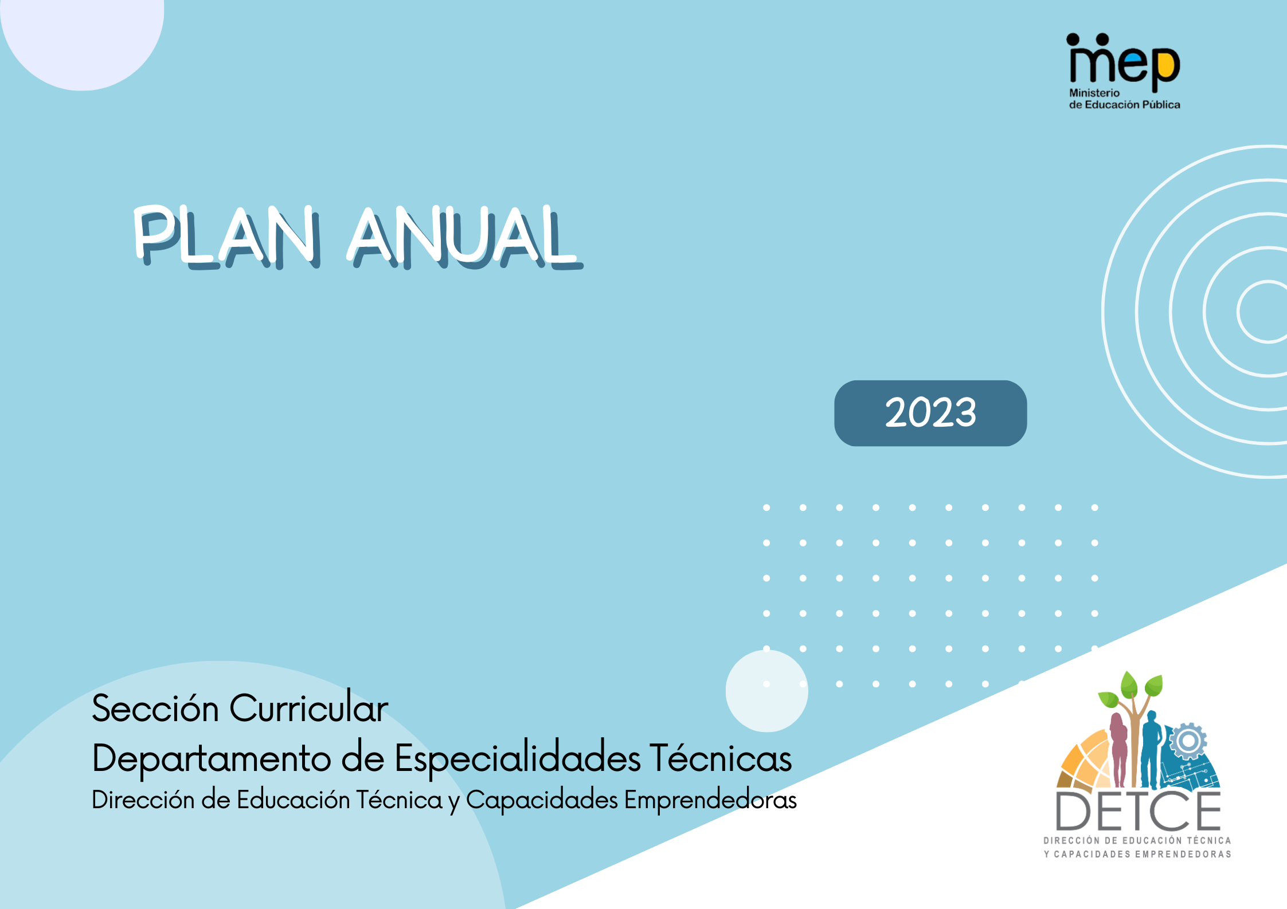

PLAN ANUAL
Centro educativo:
Especialidad:
Subárea: |  |  |  |  |  |  |  |  |  |  |  |  |  |  |  |  |  |  |  |  |  |  |  |  | Nivel:
Nombre del docente: |  |  |  |  |  |  |  |  |  |  |  |  |  |  |  |  |  |  |  |  |  |  |  |  | Año:
Unidades de estudio  y resultados de aprendizaje | Febrero |  |  |  | Marzo |  |  |  | Abrl |  |  |  | Mayo |  |  |  | Junio |  |  |  | Julio |  |  |  |  | Agosto |  |  |  | Setiembre |  |  |  | Octubre |  |  |  | Noviembre |  |  |  | Diciembre |  |  |  | Tiempo (horas)
 | 1 | 2 | 3 | 4 | 1 | 2 | 3 | 4 | 1 | 2 | 3 | 4 | 1 | 2 | 3 | 4 | 1 | 2 | 3 | 4 | 1 | 2 | 3 | 4 |  | 1 | 2 | 3 | 4 | 1 | 2 | 3 | 4 | 1 | 2 | 3 | 4 | 1 | 2 | 3 | 4 | 1 | 2 | 3 | 4
Unidad de estudio/
Resultados de aprendizaje
Recursos educativos

Plan de Práctica Pedagógica para Talleres Exploratorios de Educación General Básica de Colegios Técnicos Profesionales
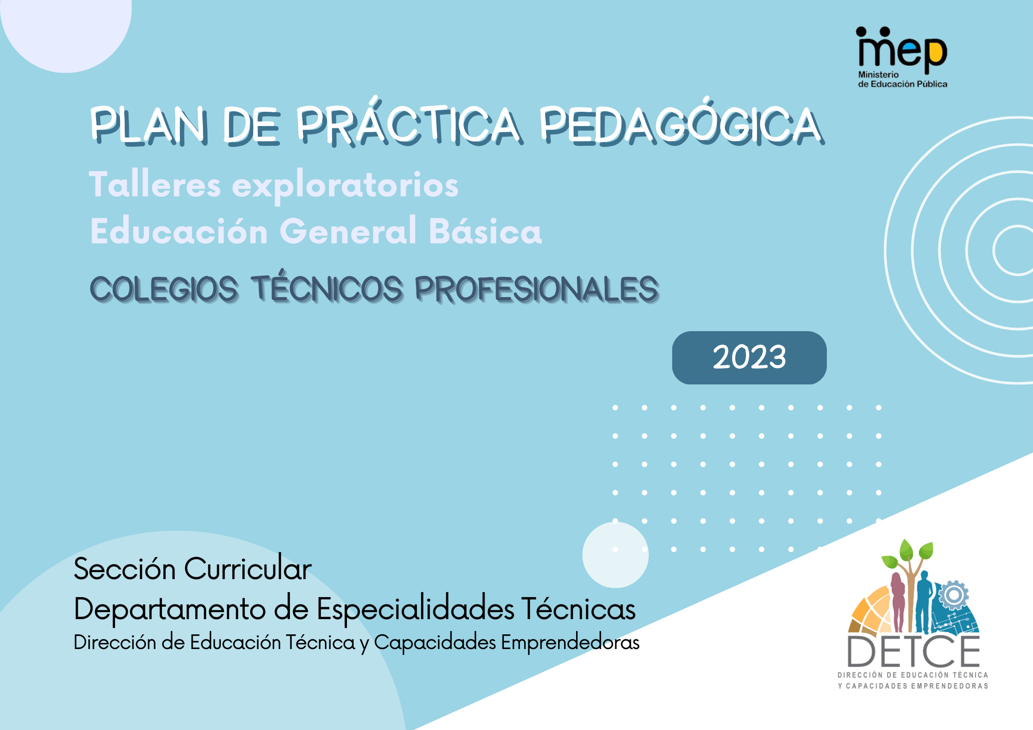

PLAN DE PRÁCTICA PEDAGÓGICA
Centro educativo: CTP
Nombre de la persona docente: | Nivel: Elija un elemento. |  | Curso lectivo: 2023
Taller exploratorio: |  |  | Modalidad: Elija un elemento.
Unidad de estudio: |  |  | Tiempo estimado:
Objetivo general: |  | Valores y actitudes:

Objetivos específicos | Contenidos | Estrategias para la mediación pedagógica | Evidencias de aprendizaje | Tiempo estimado (horas)

Plan de Práctica Pedagógica para Subáreas de los Programas de Estudio de Especialidades Técnicas Elaboradas bajo el Modelo de Educación Basado en Normas por Competencia (EBNC)
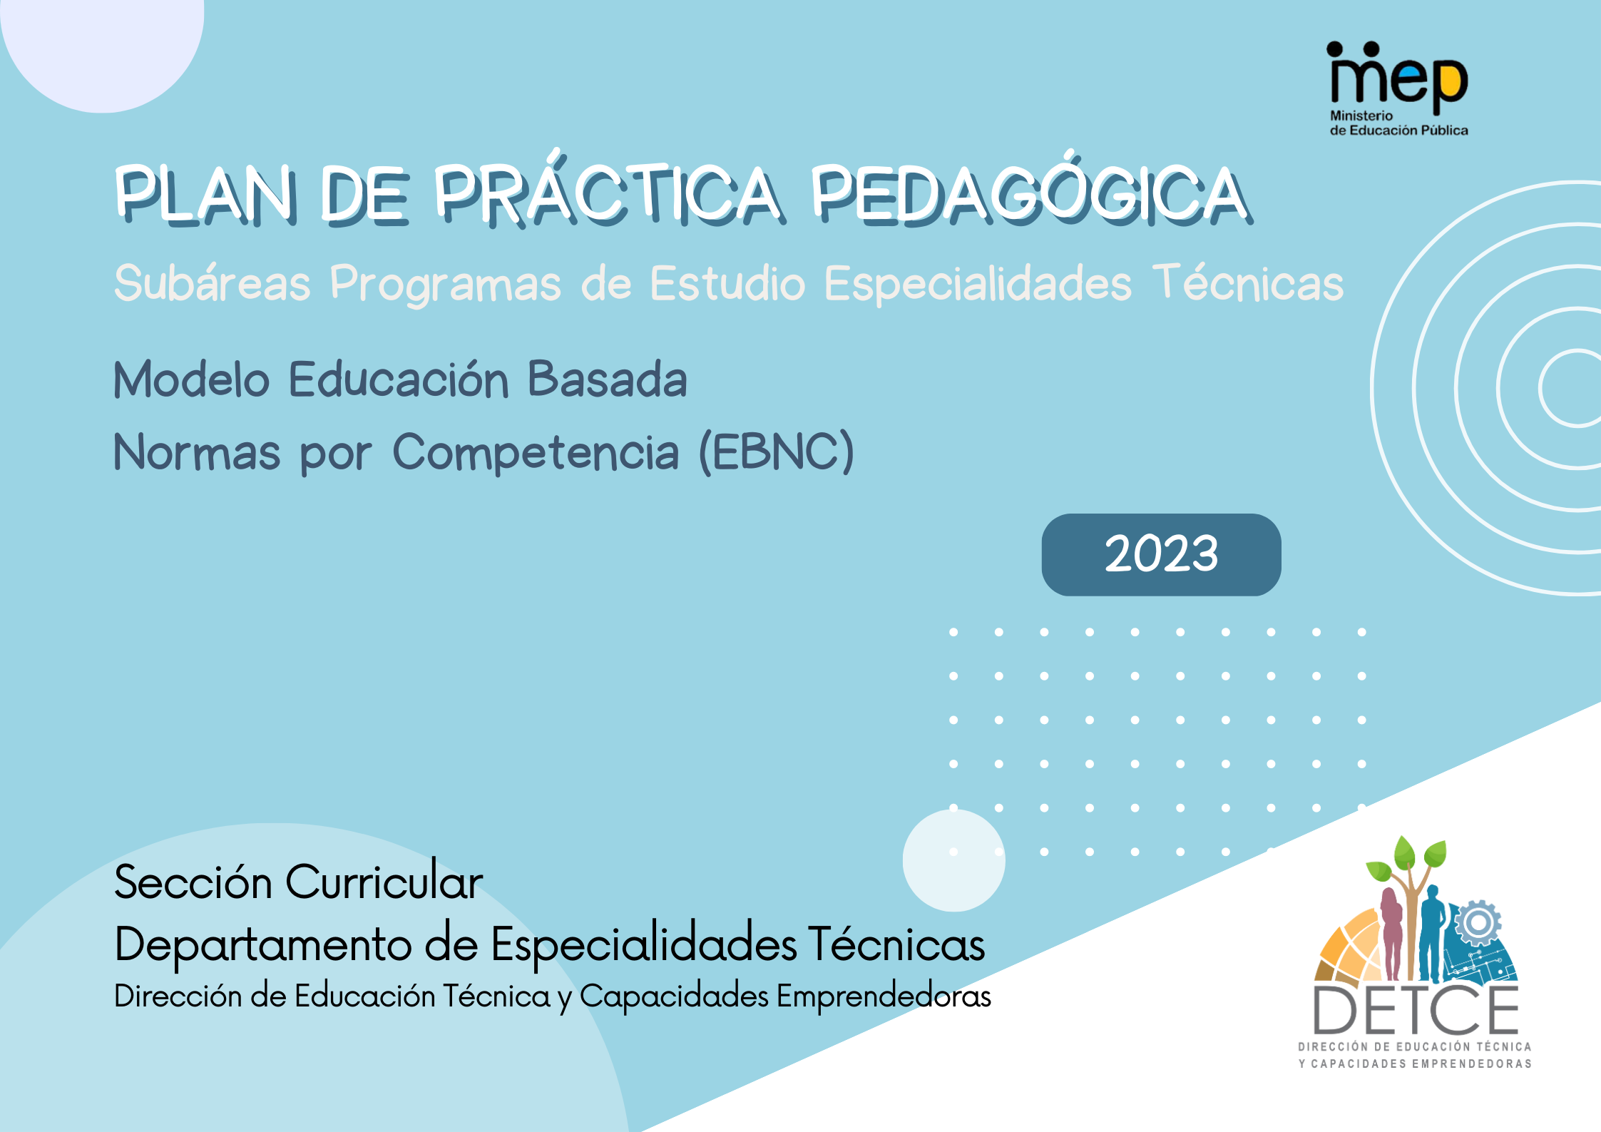

PLAN DE PRÁCTICA PEDAGÓGICA
Centro educativo: CTP
Nombre de la persona docente: |  | Nivel: |  | Curso lectivo: 2023
Especialidad: |  |  |  | Modalidad: Elija un elemento.
Subárea: | Unidad de estudio: |  |  | Tiempo estimado: horas
Propósito: |  |  | Valores y actitudes:

Resultados de aprendizaje | Contenidos | Estrategias para la  mediación pedagógica | Evidencias de aprendizaje | Tiempo estimado (horas)
 |  | D/  E/ | Conocimiento  Desempeño  Producto
2. |  | D/  E/ | Conocimiento  Desempeño  Producto
3. |  | D/  E/ | Conocimiento  Desempeño  Producto
3. |  | D/  E/ | Conocimiento  Desempeño  Producto
Observaciones

D/ Docente
E/ Estudiante

Plan de Práctica Pedagógica para Subáreas de los Programas de Estudio de Especialidades Bilingües
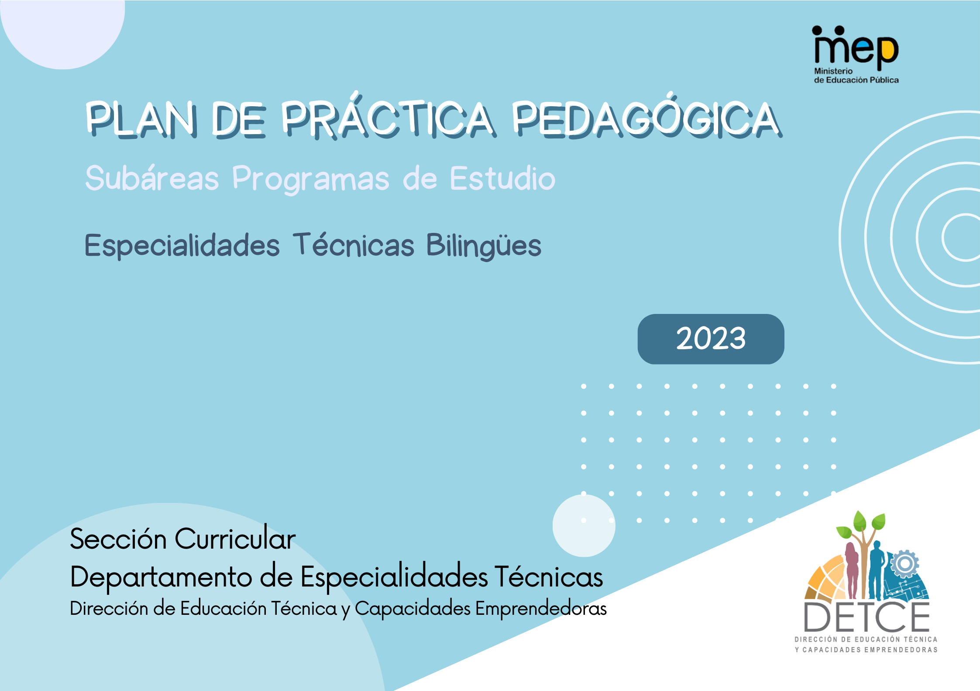

PEDAGOGICAL PRACTICE PLAN
Institution:
Teacher: |  | Level: |  | Year: 2023
Bilingual Specialty: |  |  |  | Modality:
Subject Area: | Unit of Study: |  |  | Time: horas
Purpose: |  |  | Values and attitudes:

Learning Results | Content | Pedagogical Mediation Strategies | Evidence of learning | Time  (hours)
 |  | T/  S/ | knowledge  Performance  Product
2. |  | T/  S/ | knowledge  Performance  Product
3. |  | T/  S/ | knowledge  Performance  Product
3. |  | T/  S/ | knowledge  Performance  Product
Observations

T/ Teacher
S/ Student
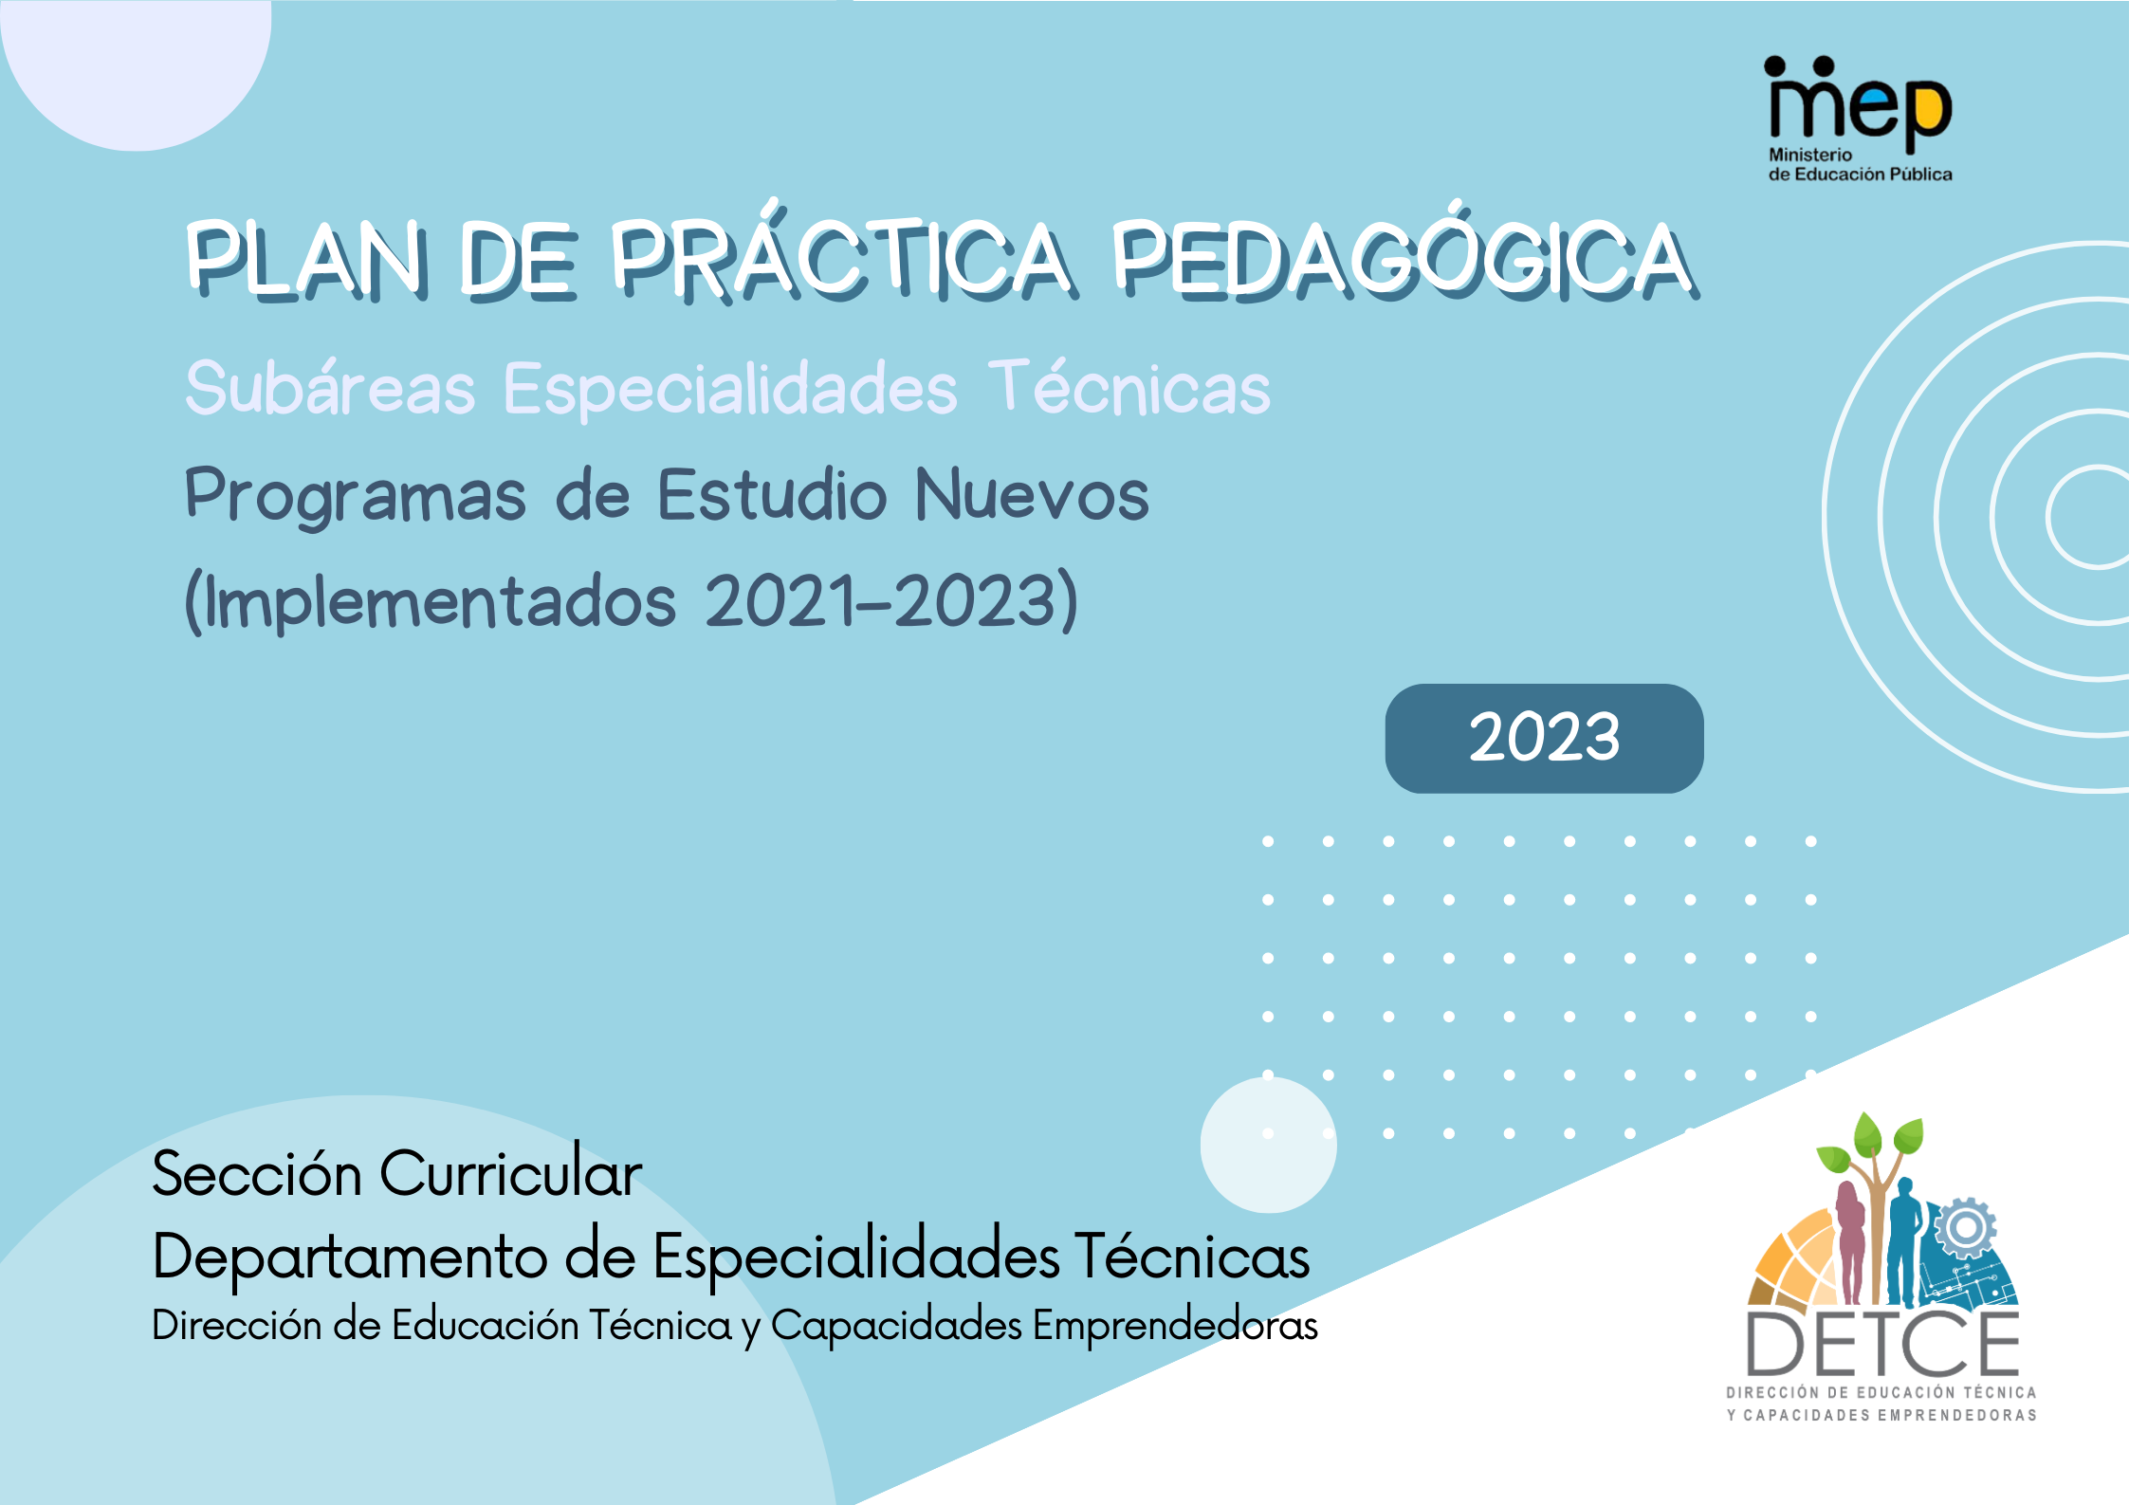

Plan de Práctica Pedagógica para Subáreas de Especialidades Técnicas con Programas de Estudio Nuevos (Implementados 2021-2023)

PLAN DE PRÁCTICA PEDAGÓGICA
Centro educativo: CTP

Nombre de la persona docente: |  | Nivel: |  | Curso lectivo: 2023
Especialidad: | Modalidad: Elija un elemento. |  |  |  | Campo detallado:
Subárea: | Unidad de estudio: |  |  |  | Tiempo estimado:
Competencias para el desarrollo humano:  Elija un elemento. |  |  | Eje de la política educativa: Elija un elemento.

Resultados de aprendizaje | Saberes esenciales | Estrategias para  la mediación pedagógica | Evidencias de aprendizaje | Tiempo estimado (horas)
 |  | D/  E/ | Conocimiento  Desempeño  Producto
 |  | D/  E/ | Conocimiento  Desempeño  Producto
 |  | D/  E/ | Conocimiento  Desempeño  Producto
 |  | D/  E/ | Conocimiento  Desempeño  Producto
Observaciones

D/ Docente
E/ Estudiante

Plan de Práctica Pedagógica para los Talleres y Tecnologías Ofertados en los Colegios Académicos Diurnos
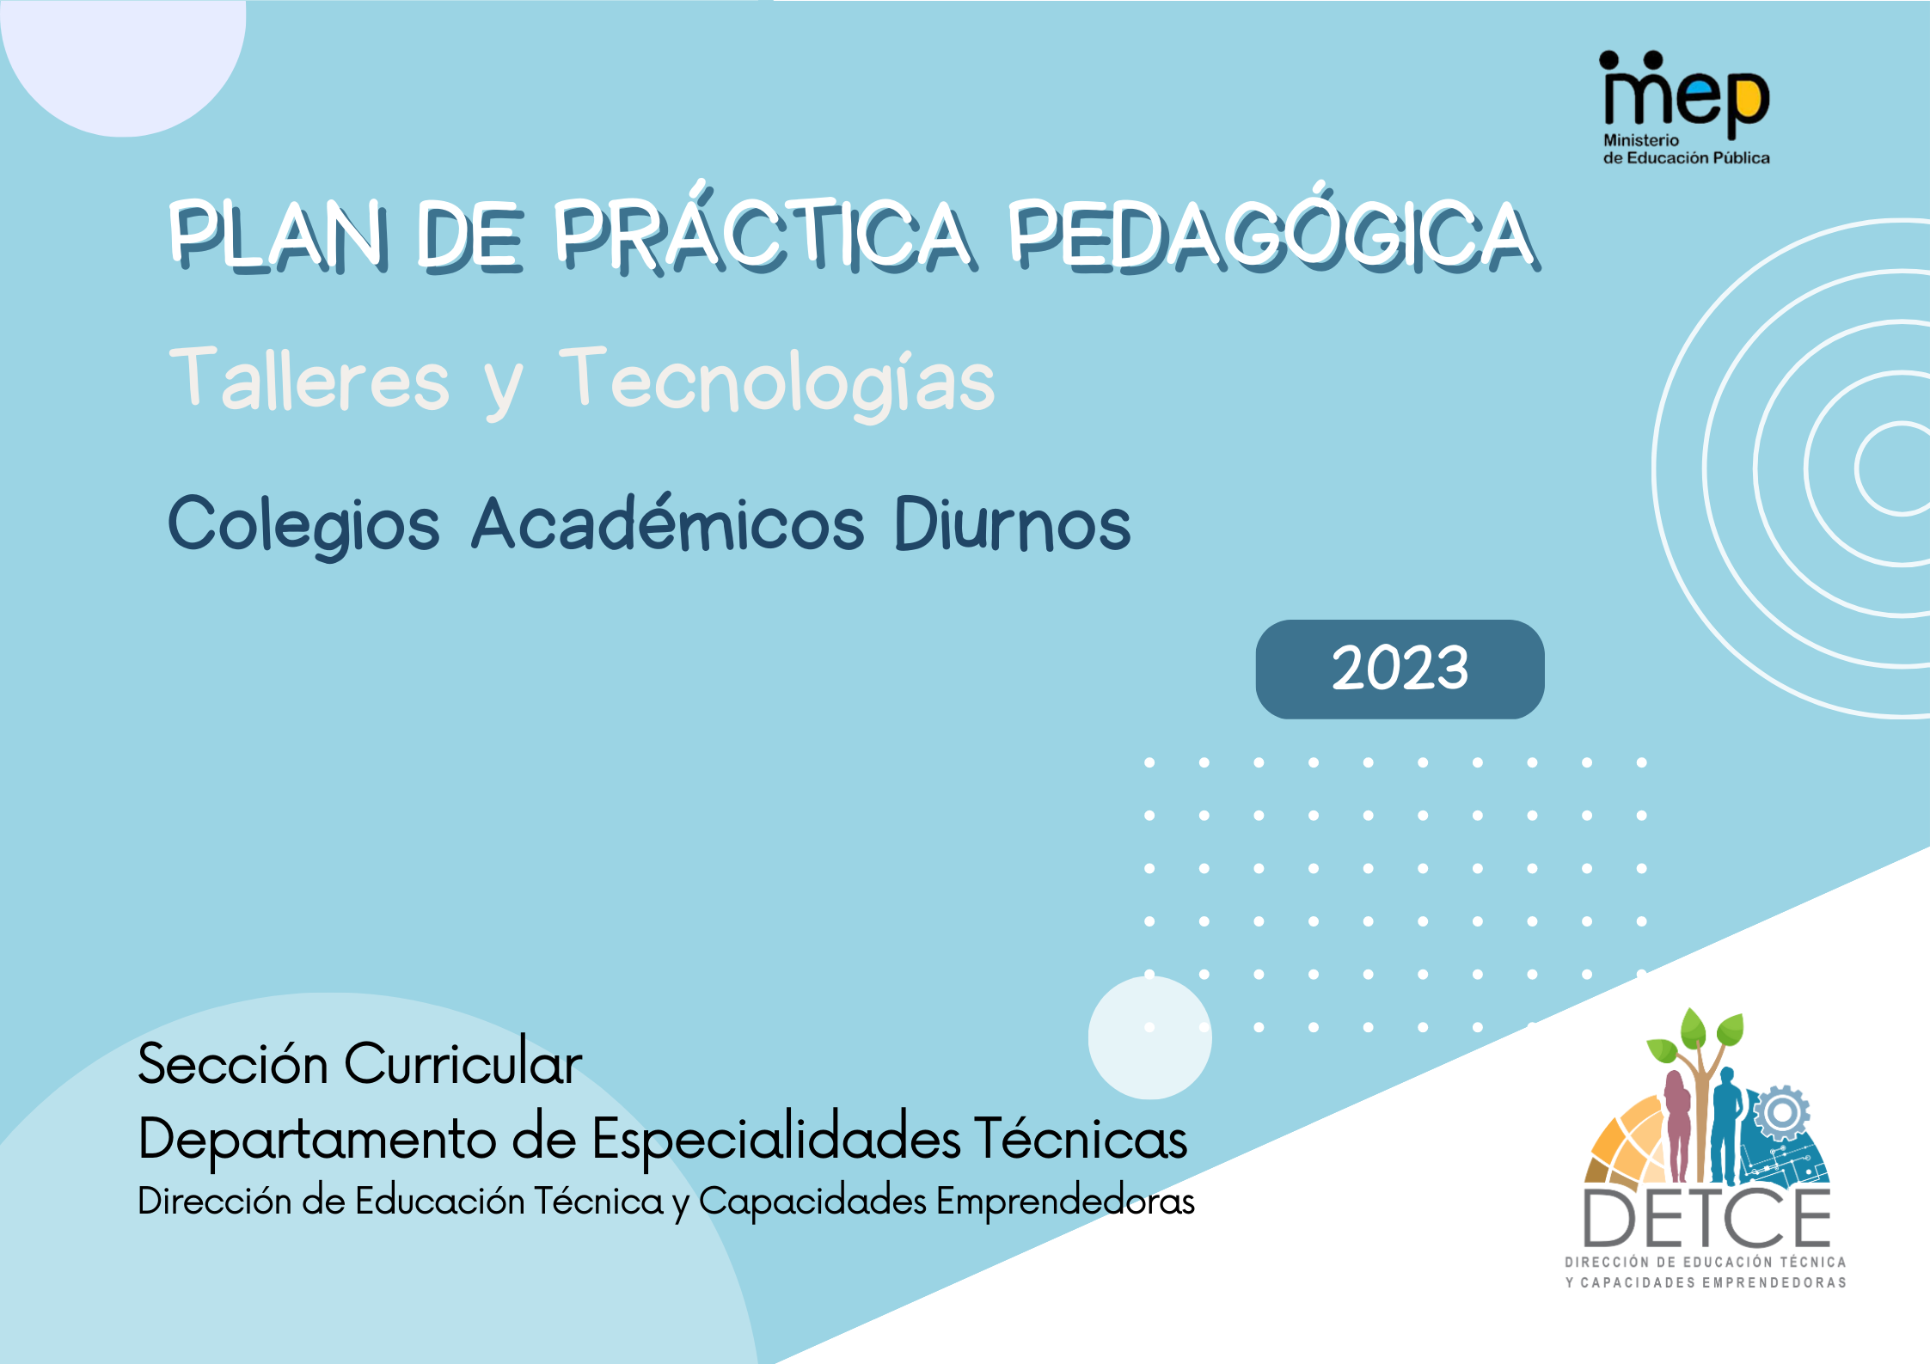

PLAN DE PRÁCTICA PEDAGÓGICA
Centro educativo: Colegio
Nombre de la persona docente: | Nivel: Elija un elemento. |  |  | Curso lectivo: 2023
Taller /tecnología: |  |  | Modalidad: Elija un elemento.
Unidad de estudio: |  |  | Tiempo estimado:
Objetivo general: |  | Valores y actitudes:

Objetivos específicos | Contenidos | Estrategias para  la mediación pedagógica | Evidencias de aprendizaje | Tiempo estimado (horas)
D/
E/
D/
E/
3. |  | D/  E/
4. |  | D/  E/
Observaciones:

D/ Docente
E/ Estudiante

Pedagogical Practice Plan Conversational English (7th-8th-9th). Subject Area: English Oriented to…
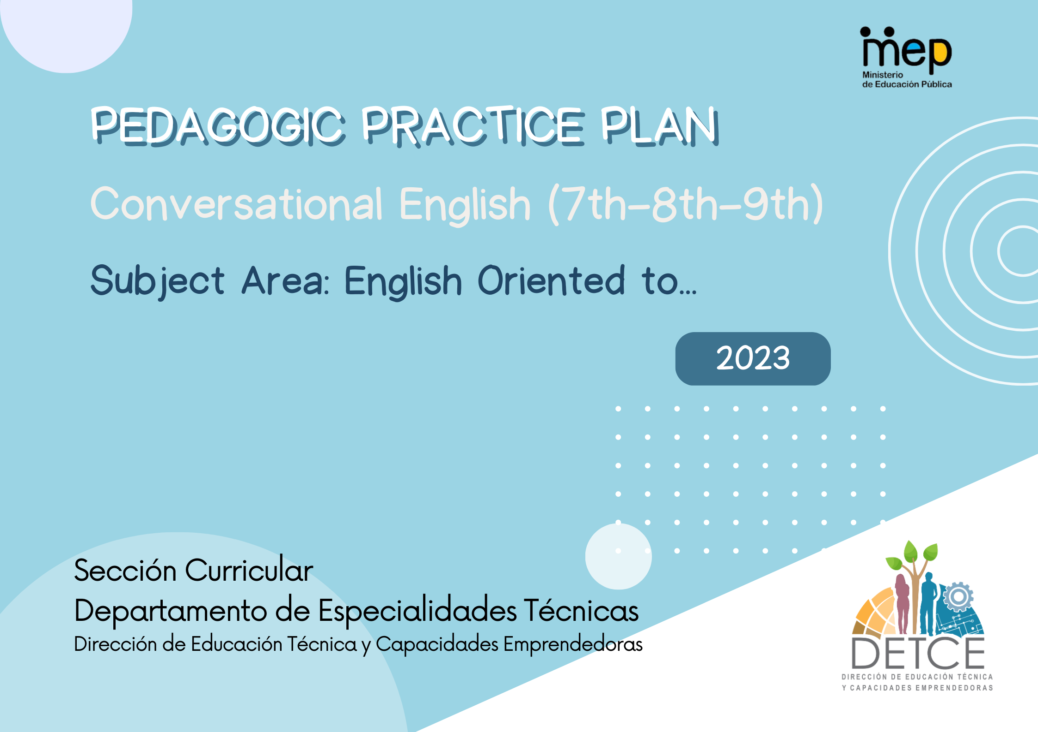

Pedagogical Practice Plan

Institution: |  | CEFR: Elija un elemento.
Teacher: |  | Level:
Subject Area: English Oriented to… | Scenario: |  | Time:
Essential question: | Theme:
Essential Competence: Elija un elemento. | New Citizenship Axis: Elija un elemento.

Goals | Task Mediation Activity | Indicators
Essential Competence

New Citizenship Axis

Oral and Written Comprehension | Task-Building Process:  Pre-Task:  - Create opportunities for schemata-building to introduce the meaning of unknown vocabulary, structures and functions as mentioned.  Task Rehearsal:  - Expose learners to authentic materials to deal with…  - Focus on linguistic elements such as functions, discourse markers, grammar and vocabulary related to the field of study.  - Give learners controlled practice in using the target language, vocabulary, structures and functions.  Post Task  - Engage learners to meaningful productive tasks based on the field of study.  Assessment:  Project: integration of activities. It has to be done in class during the whole period.
Listening:

Reading:

Oral and Written Comprehension

Spoken Interaction

Spoken Production:

Writing:

Resources: Haga clic aquí para escribir texto.
Classroom: Haga clic aquí para escribir texto.
English Laboratory: Haga clic aquí para escribir texto.
Devices: Haga clic aquí para escribir texto.
Materials: Haga clic aquí para escribir texto.

Pedagogical Practice Plan Conversational English Technology - Subject Area: English of the Specialities EBNC
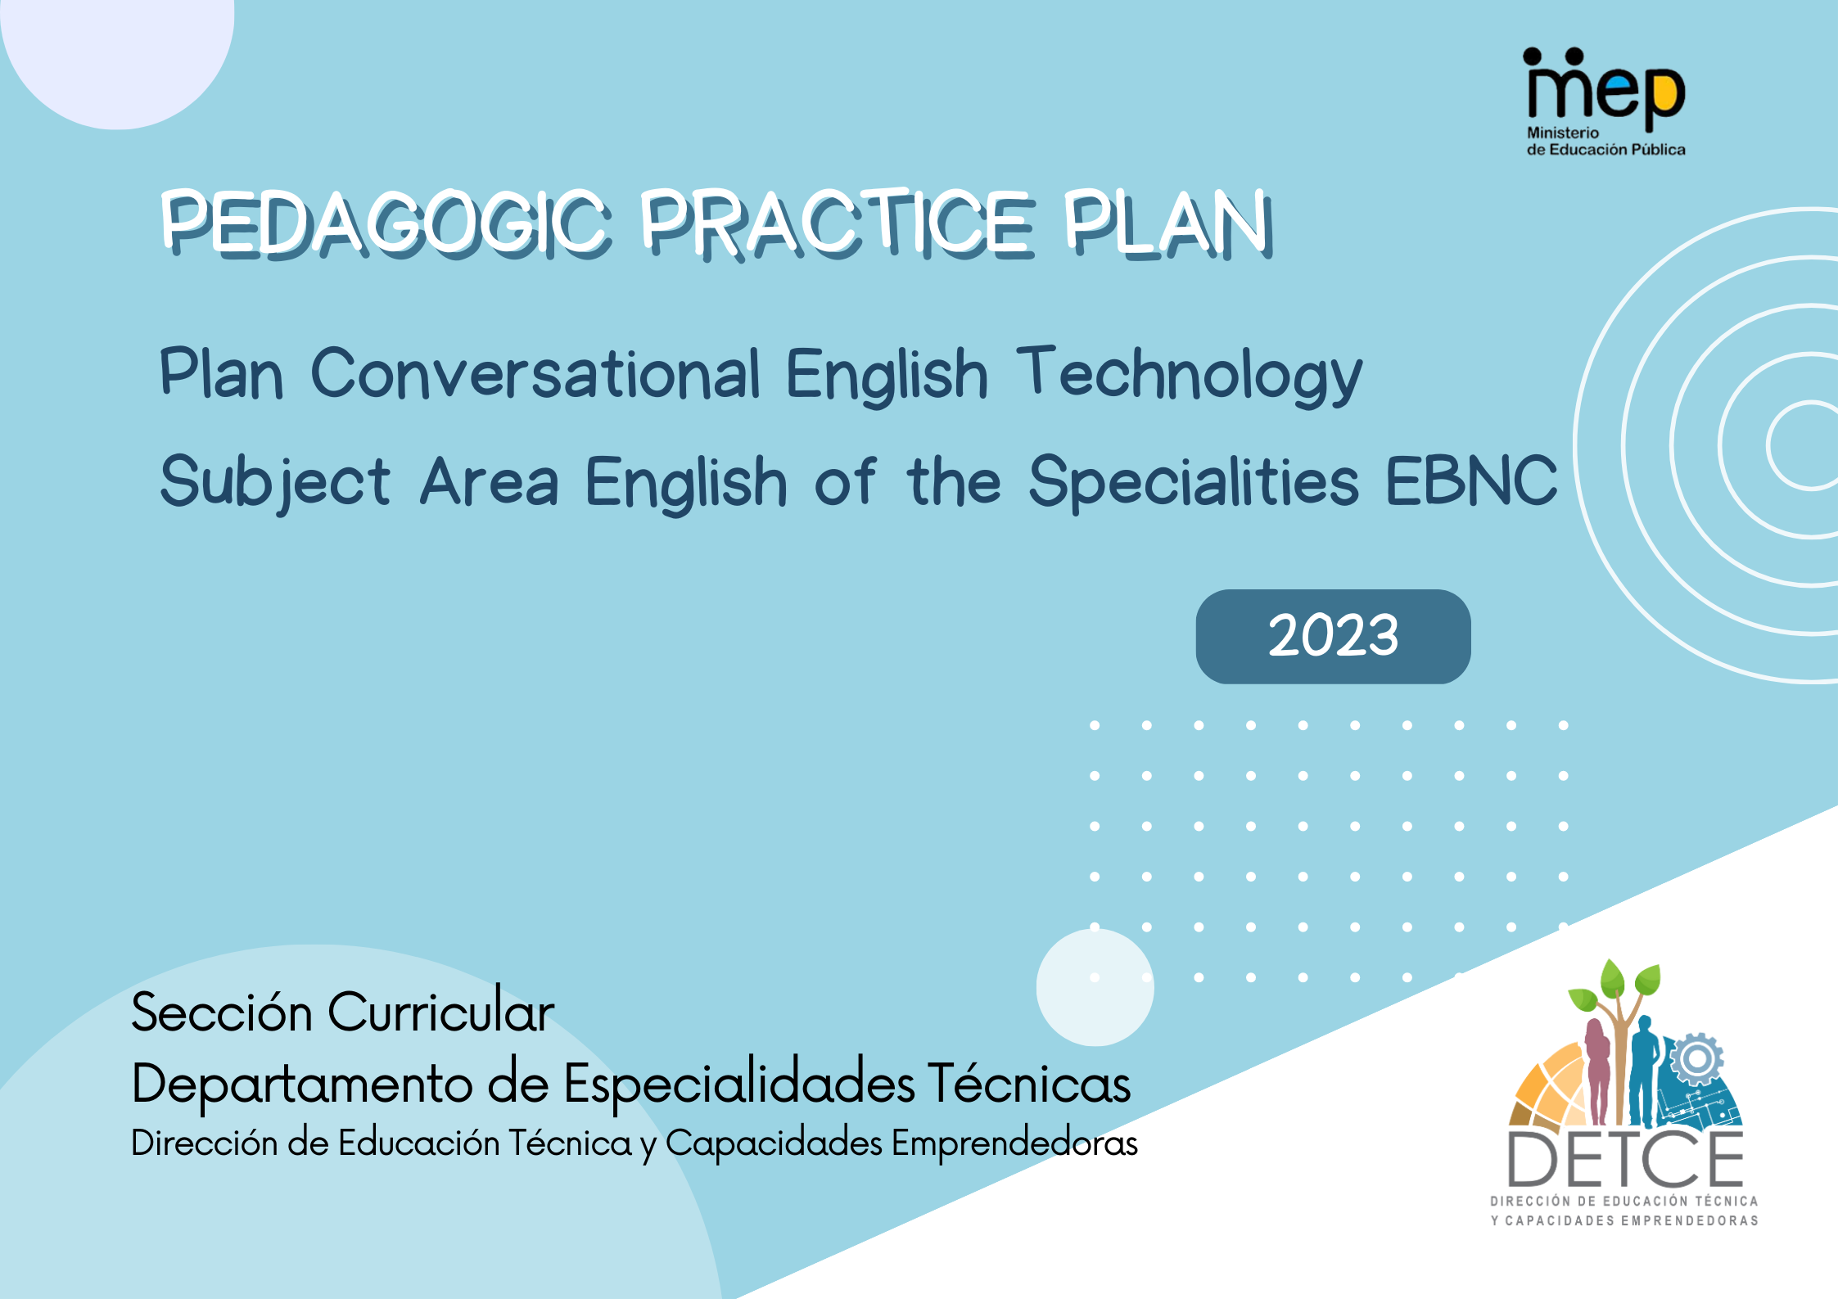

Pedagogical Practice Plan

Institution:

Teacher: |  | Level:
Subject Area: English for ….. | Specialty: |  | Time:

Linguistic Achievements | Task Mediation Activity | Indicators
Oral and Written Comprehension | Task-Building Process:  Pre-Task:  - Create opportunities for schemata-building to introduce the meaning of unknown vocabulary, structures and functions as mentioned.  Task Rehearsal:  - Expose learners to authentic materials to deal with…  - Focus on linguistic elements such as functions, discourse markers, grammar and vocabulary related to the field of study.  - Give learners controlled practice in using the target language, vocabulary, structures and functions.  Post Task  - Engage learners to meaningful productive tasks based on the field of study.  Assessment:  Project: integration of activities. It has to be done in class during the whole period.
Listening:

Reading:

Oral and Written Comprehension

Speaking:

Writing:

Resources: Haga clic aquí para escribir texto.
Classroom: Haga clic aquí para escribir texto.
English Laboratory: Haga clic aquí para escribir texto.
Devices: Haga clic aquí para escribir texto.
Materials: Haga clic aquí para escribir texto.

Annual Plan
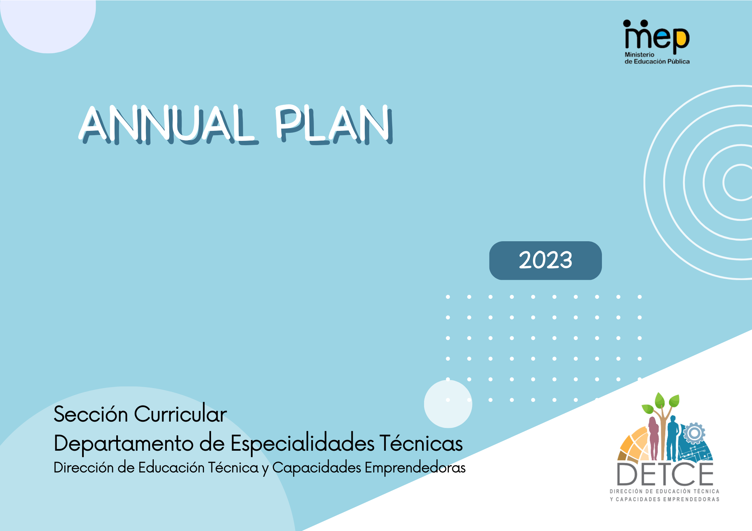

ANNUAL LEARNING PLAN
Technical High School:
Subject Area: |  |  |  |  |  |  |  |  |  |  |  |  |  |  |  |  |  |  |  |  |  |  |  |  | Level:
Teacher: |  |  |  |  |  |  |  |  |  |  |  |  |  |  |  |  |  |  |  |  |  |  |  |  | Year:
Scenarios  Themes  and  Goals  Weeks | February |  |  |  | March |  |  |  | April |  |  |  | May |  |  |  | June |  |  |  | July |  |  |  |  | August |  |  |  | September |  |  |  | October |  |  |  | November |  |  |  | December |  |  |  | Time (Hours)
 | 1 | 2 | 3 | 4 | 1 | 2 | 3 | 4 | 1 | 2 | 3 | 4 | 1 | 2 | 3 | 4 | 1 | 2 | 3 | 4 | 1 | 2 | 3 | 4 |  | 1 | 2 | 3 | 4 | 1 | 2 | 3 | 4 | 1 | 2 | 3 | 4 | 1 | 2 | 3 | 4 | 1 | 2 | 3 | 4
Scenario
Themes
Goals

